

**IS20XX Bluetooth®**

**Evaluation Board User’s Guide**

**Index**

Preface 4

1 OVERVIEW 6

1.1 INTRODUCTION 6

1.2 IS20XX EVALUATION BOARD FEATURES 6

1.3 IS20XX EVALUATION BOARD CONTENTS 7

2. Getting Started 10

2.1 INTRODUCTION 10

2.2 HARDWARE REQUIREMENTS 10

2.3 APPLICATION DEMONSTRATION 10

2.4 Software/Utility Requirements 13

2.5 Silicon Configuration 25

Appendix A. IS2010 Audio Evaluation Board Schematics 26

Appendix B. UART DAUGHTER BOARD (EDGAR) 32

**TO OUR VALUED CUSTOMERS**

It is our intention to provide our valued customers with the best documentation possible to ensure successful use of your Microchip products. To this end, we will continue to improve our publications to better suit your needs. Our publications will be refined and enhanced as new volumes and updates are introduced.

If you have any questions or comments regarding this publication, please contact the Marketing Communications Department via E-mail at [**docerrors@microchip.com**](mailto:docerrors@microchip.com). We welcome your feedback.

##### Most Current Data Sheet

To obtain the most up-to-date version of this data sheet, please register at our Worldwide Web site at:

[**http://www.microchip.com**](http://www.microchip.com/)

You can determine the version of a data sheet by examining its literature number found on the bottom outside corner of any page. The last character of the literature number is the version number, (e.g., DS30000000A is version A of document DS30000000).

##### Errata

An errata sheet, describing minor operational differences from the data sheet and recommended workarounds, may exist for current devices. As device/documentation issues become known to us, we will publish an errata sheet. The errata will specify the revision of silicon and revision of document to which it applies.

To determine if an errata sheet exists for a particular device, please check with one of the following:

* + - Microchip’s Worldwide Web site; [**h**](http://www.microchip.com/)**ttp**[**://www**](http://www.microchip.com/)**.m**[**icrochip.co**](http://www.microchip.com/)**m**
    - Your local Microchip sales office (see last page)

When contacting a sales office, please specify which device, revision of silicon and data sheet (include literature number) you are using.

##### Customer Notification System

Register on our web site at [**www.microchip.com**](http://www.microchip.com/) to receive the most current information on all of our products.

**Abbreviations List:**

**HFP:** Hands-free Profile

**AVRCP:** Audio Video Remote Control Profile

**A2DP:** Advanced Audio Distribution Profile

**HSP:** Headset Profile

**NFC:** Near Field Communication

# Preface

|  |
| --- |
| **NOTICE TO CUSTOMERS** |
| All documentation becomes dated, and this manual is no exception. Microchip tools and documentation are constantly evolving to meet customer needs, so some actual dialogs and/or tool descriptions may differ from those in this document. Please refer to our web site  (www.microchip.com) to obtain the latest documentation available. |

**INTRODUCTION**

This chapter contains general information that will be useful to know before using the

Product Name. Items discussed in this chapter include:

* Document Layout
* Recommended Reading
* The Microchip Web Site
* Customer Support
* Document Revision History

**DOCUMENT LAYOUT**

This user’s guide describes how to use the IS2010 Bluetooth Evaluation Board. The document is organized as follows:

* Chapter 1. “Overview” – This chapter introduces the IS2010 Bluetooth Evaluation Board and provides an overview of various features.
* Chapter 2. “Getting Started” – This chapter describes
* The hardware components and setup of the IS2010 Bluetooth Evaluation Board.
* The application demonstrations of the IS2010 Bluetooth Evaluation Board.
* Software/Utility Requirements of the IS2010 Bluetooth Evaluation Board.
* Appendix A. “IS2010 Audio Evaluation Board Schematics” – This appendix includes a schematic of the IS2010 Bluetooth Evaluation Board.

**RECOMMENDED READING**

This user’s guide describes how to use the IS2010 Bluetooth Evaluation Board. Other useful documents are listed below. The following Microchip documents are available and recommended as supplemental reference resources:

STEREO Silicon Data Sheet (DSxxxxxxxx)

**THE MICROCHIP WEB SITE**

Microchip provides online support via our web site at http://www.microchip.com. This

web site is used as a means to make files and information easily available to

customers. Accessible by using your favorite Internet browser, the web site contains

the following information:

* Product Support – Data sheets and errata, application notes and sample programs, design resources, user’s guides and hardware support documents, latest software releases and archived software
* General Technical Support – Frequently Asked Questions (FAQs), technical support requests, online discussion groups, Microchip consultant programmember listing
* Business of Microchip – Product selector and ordering guides, latest Microchip press releases, listing of seminars and events, listings of Microchip sales offices, distributors and factory representatives

**CUSTOMER SUPPORT**

Users of Microchip products can receive assistance through several channels:

* Distributor or Representative
* Local Sales Office
* Field Application Engineer (FAE)
* Technical Support

Customers should contact their distributor, representative or Field Application Engineer

(FAE) for support. Local sales offices are also available to help customers. A listing of

sales offices and locations is included in the back of this document.

Technical support is available through the web site at: http://support.microchip.com

**DOCUMENT REVISION HISTORY**

Revision A (Aug 2015)

This is the initial released version of this document.

# 1 OVERVIEW

## 1.1 INTRODUCTION

This user’s guide describes the hardware and software setup for the IS20XX Bluetooth® Evaluation Board. This board contains the hardware needed to evaluate the IS20XX Bluetooth silicon. The IS20XX silicon is mounted to an evaluation board that demonstrates the silicon’s key features. The evaluation board contains:

* Audio output
* Easy access to IO pins
* 6 push buttons to control audio playback
* Status LEDs
* The IS20XX supports the following Bluetooth profiles: A2DP, AVRCP, and HFP/HSP
* A2DP stereo audio (Sink mode support for Sub-Band Coding (SBC)),
* AVRCP media player remote control
* HFP/HSP for accepting a phone call support.

For data sheet and other details related to IS20XX silicon, refer to the Microchip web

site at http://www.microchip.com.

This chapter discusses the following topics:

* IS20XX Evaluation Board Features
* IS20XX Evaluation Board Contents and Part Details

## 1.2 IS20XX EVALUATION BOARD FEATURES

The IS20XX Evaluation Board has the following features:

* Fully qualified Bluetooth version 4.1 silicon, fully compatible with Bluetooth version 3.0, 2.0, 1.2 system.
* Embedded Bluetooth stack profiles: A2DP, AVRCP, and HFP/HSP
* Stereo audio output for highest quality audio
* Environmentally friendly, RoHS compliant
* Provide SMA connector for RF signal connection.

## 1.3 IS2010 EVALUATION BOARD CONTENTS

IS20XX Evaluation Board contains the following components as shown in Figure 1-1 which describes the evaluation board’s interfaces and connectors. Table 1-1 describes the various components of the evaluation board.

FIGURE 1-1: IS2010 EVALUATION BOARD

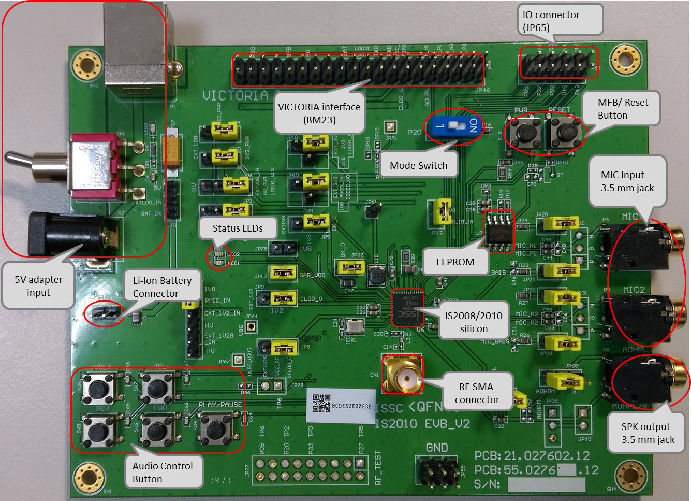

Battery connector (JP2)



|  |  |
| --- | --- |
| Pin | Description |
| 1 | BAT_IN |
| 2 | GND |
|  |  |
|  |  |
|  |  |

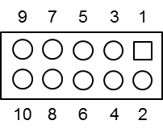IO Connector (J65)

|  |  |  |  |
| --- | --- | --- | --- |
| Pin | Description | Pin | Description |
| 1 | P1_2 | 6 | P0_2 |
| 2 | P1_3 | 7 | P2_0 |
| 3 | P0_1 | 8 | P2_7 |
| 4 | P1_5 | 9 | NC |
| 5 | P0_3 | 10 | P0_5 |
|  |  |  |  |

TABLE 1-1:IS2010 EVALUATION BOARD HARDWARE

|  |  |
| --- | --- |
| **Hardware Component** | **Description** |
| IS20XX | Bluetooth® 4.1 Silicon |
| 5V Adaptor Input | DC 5V input, from USB or 5V adaptor |
| BAT connector | JP2 for BAT_IN |
| Audio Out | Audio 3.5 mm jack for audio playback(P6). |
| Audio In | Audio 3.5 mm jack for Mono microphone input(P4/P5) |
| Status LEDs | Red and Blue LEDs show the pairing/connection status |
| PWR Button | Switch to turn on/off IS2010 silicon (SW9; Button 0 in UI) |
| Play/Pause Button | Button to play or pause the audio playback (SW4; Button1 in UI) |
| Previous Track Button | Button to skip track backwards (SW5; Button 5 in UI) |
| Next Track Button | Button to skip track forwards(SW6; Button 4 in UI) |
| Volume Up Button | Button to increase volume (SW8; Button 2 in UI) |
| Volume Down Button | Button to decrease volume (SW7; Button 3 in UI) |
| Reset Button | Reset system (SW3) |

# 2. Getting Started

## 2.1 INTRODUCTION

This chapter describes how the IS20XX Evaluation Board works. Certain hardware and utilities are essential to support the evaluation/development of demo applications. This chapter discusses the following topics:

* Hardware Requirements
* Software/Utility Requirements
* Silicon Configuration

## 2.2 HARDWARE REQUIREMENTS

**2.2.1 Hardware Setup**

To setup the evaluation hardware, perform the following steps:

1. 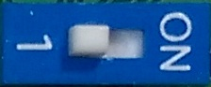Make sure pin 1 of “SW2” in “Off ” state make system in application mode.
2. Connect the portable mini-speaker 3.5 mm to the stereo audio out connector (P6).

**2.2.2 Using The Evaluation Board**

1. Connect Li-Ion batteries to JP2 or connect 5V adapter to power jack P2 and put the switch away from jack.

2. Click PWR button to turn-on and enter pairing mode. The status LEDs will blink. Now the IS2010 Evaluation board should be discoverable.

3. Turn on Bluetooth device manager on a host device (PC or smartphone), the host device will display a list of discoverable Bluetooth devices. The board display as “IS2008-002 EVB” or “IS2008-203 EVB”.

4. If the pairing with the device is successful, IS2010 evaluation board can connect to the host device. Once connected, IS2010 evaluation board enables Advanced Audio Distribution Profile (A2DP) for audio playback and Audio Video Remote Control Profile (AVRCP) for player control and Hands Free Profile(HFP) and Headset Profile(HSP).

## 2.3 APPLICATION DEMONSTRATION

**2.3.1 AUDIO DEMONSTRATION**

In this demonstration, user can play an audio stream on both IS2010 evaluation boards using a computer or smartphone. The following are the steps to perform the demonstration.

1. Connect IS2010 evaluation board to a host device (PC or smartphone) that has an audio source.
2. Connect headphones (or mini-speakers) to IS2010 evaluation board P6.
3. Open the audio source on the host device. Microchip recommends using media player.(e.g. Microsoft Media Player, iTunes, and Android).
4. Start the audio stream on the media player.

When IS2010 evaluation board is connected to an audio source compatible with Bluetooth AVRCP, the audio control buttons are used to:

* Control the volume of audio output.
* Go to the previous track.
* Go to the next track.
* Start / stop playing the current track.

FIGURE 1-2: IS2010 EVALUATION BOARD AUDIO CONTROL BUTTONS

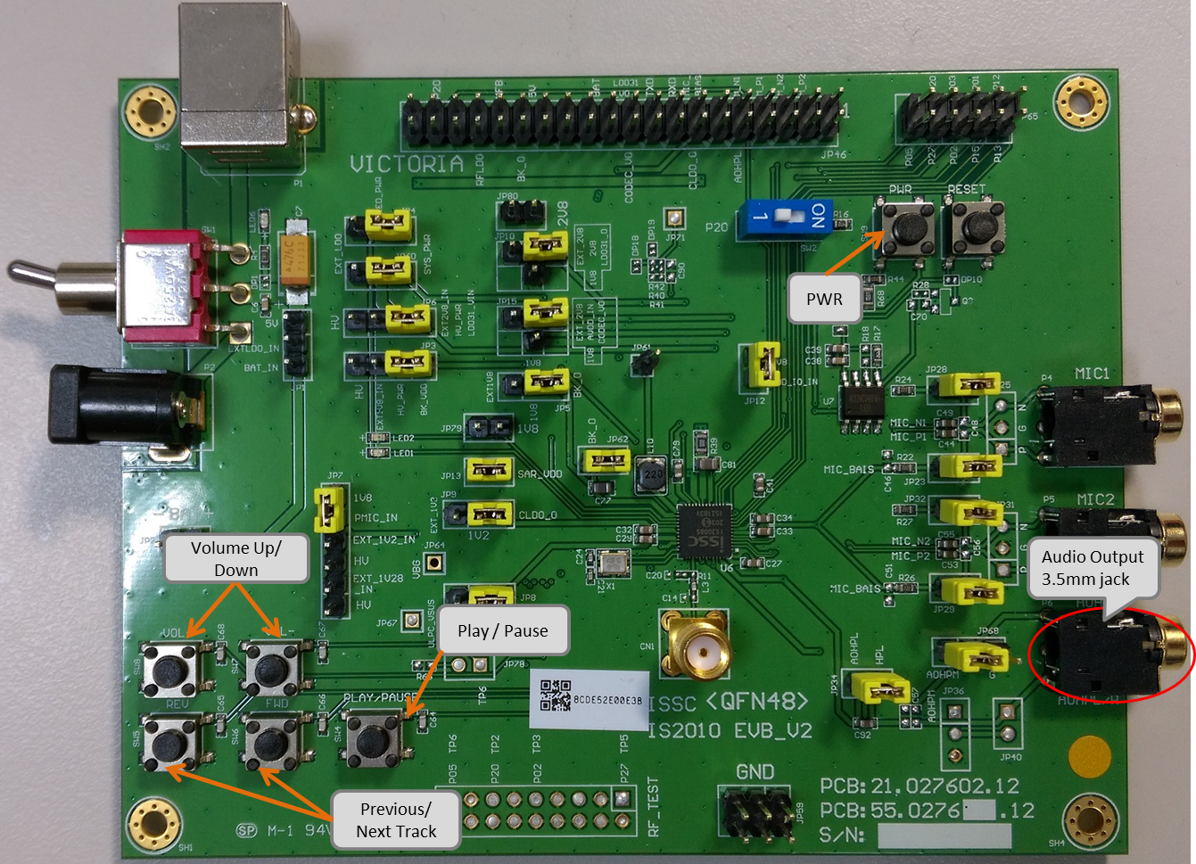

**2.3.2 HSP/HFP DEMONSTRATION**

In this demonstration, user can explore the hands-free profile setting to receive an incoming voice call from a paired smartphone. This demonstration requires a microphone. It would be good to use a PC headset/microphone (with two-plugs). The following are the steps to perform the demonstration.

1. Connect the headset/microphone to IS2010 evaluation board’s audio out connector (P6) and MIC input (P4) respectively.
2. Connect IS2010 evaluation board to a smartphone that supports the A2DP and HFP/HSP Bluetooth profiles.
3. From another one phone, initiate a call to the smartphone that is paired with IS2010 evaluation board. The A2DP stream pauses and the ringtone plays on the headset.
4. Click button “PWR” on IS2010 evaluation board to accept the incoming call.

## 2.4 Software/Utility Requirements

**2.4.1 UI SETTING**

**Step1.** Open UI tool

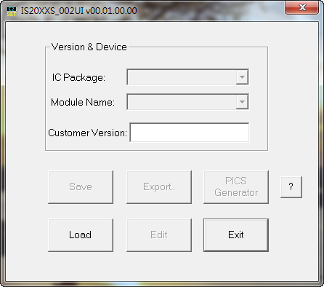

**Step2.** Firstly, you can load default UI setting or previous setting file.

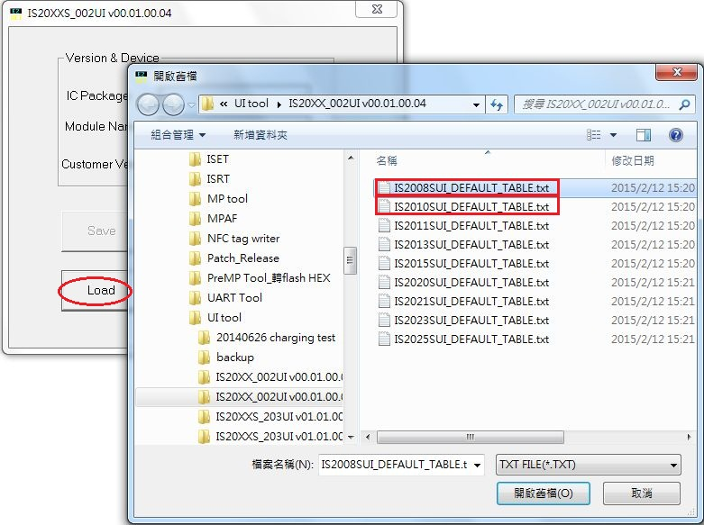

**Step3.** Click “Edit” to modify the settings meet your needs.

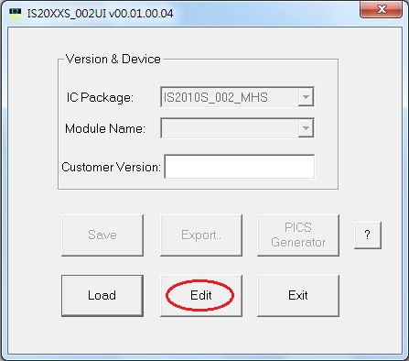

**Step4.** In the main settings, it can enable or disable supported profile or function which system need.

Click “Next” for other setting.

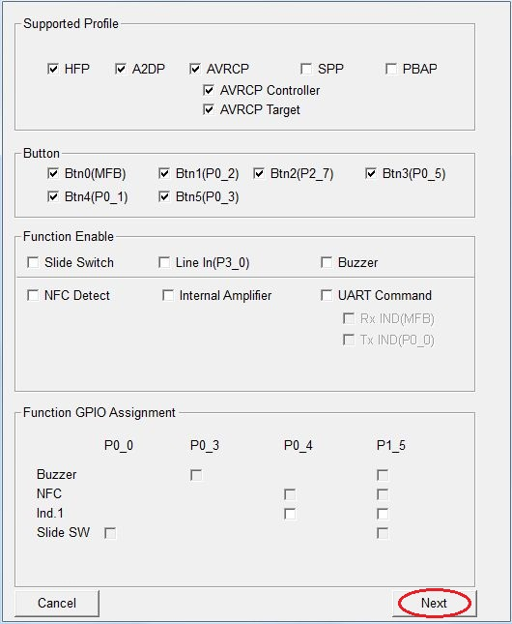

**Step5.** You can do system and functional setting in these pages.

Click “Help” you can get more detail information.

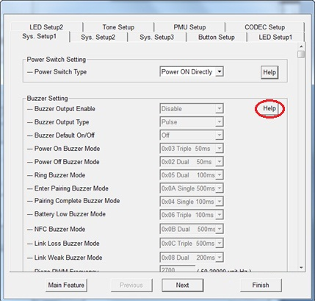

**Step6.** After finish parameter set up, click “Finish” button and a message will remind you check EEPROM

size on your system.

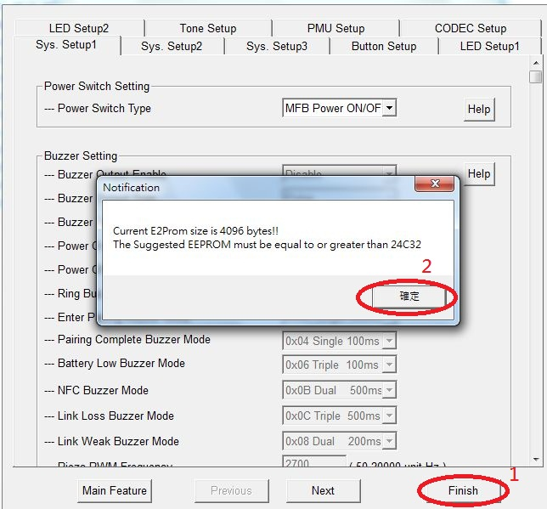

**Step7.** Click “Save” button to save these UI parameter as a “.txt” file

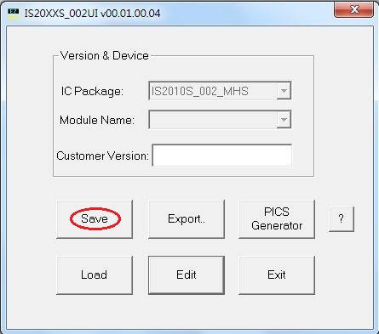

**Step8.** We will use MPET tool to merge it with EEPROM table and use EEPROM tool load these parameter to system.

**2.4.2 DSP TOOL SETTING**

**Step1.** Open DSP tool

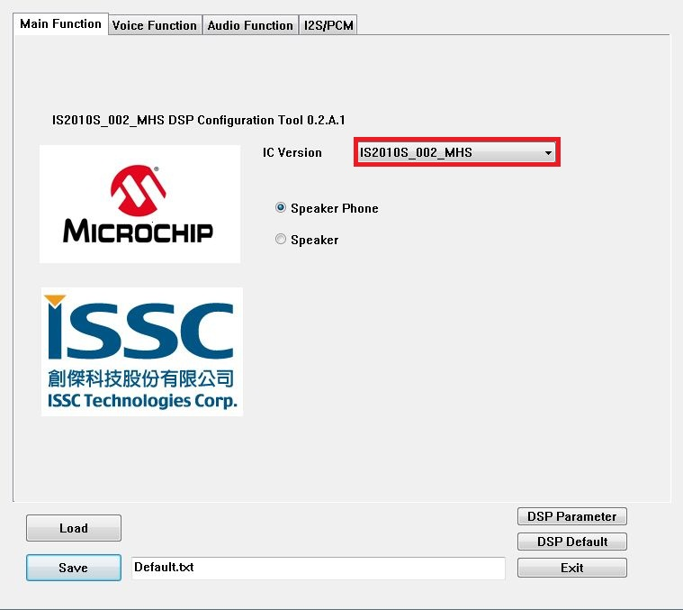**Step2.** Select IC version ““IS2010_XXX_MHS” (XXX is the version of chip, e.g. IS2010S-002)

**Step3.** You can setup all voice and audio function in these pages.

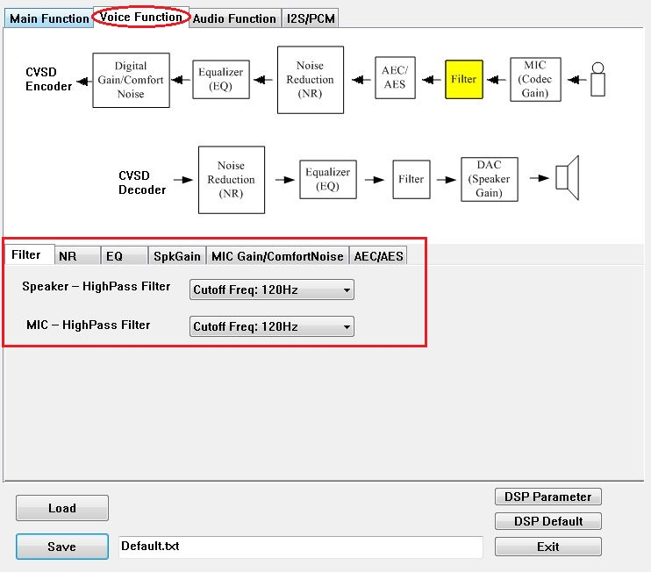

**Step4.** Click “Save” button to save these DSP parameter as a “.txt” file after finish all DSP setting. Then use MPET tool to merge it with EEPROM table and use EEPROM tool load these parameter to system.

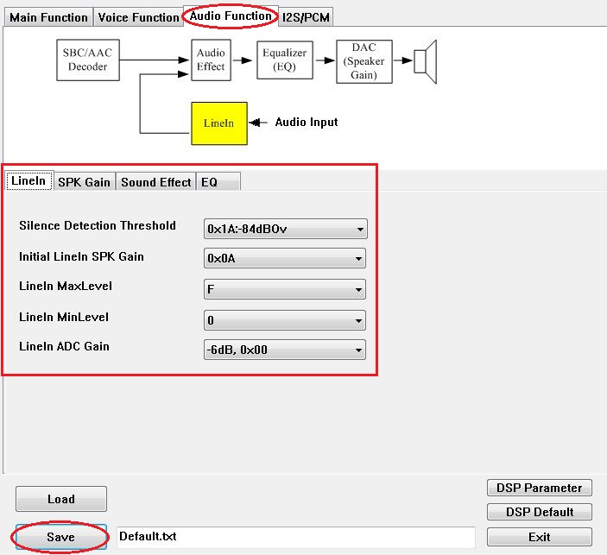

**2.4.3 MERGE TOOL SETTING**

**Step1.** Open MPET tool, click “Next” to set up.

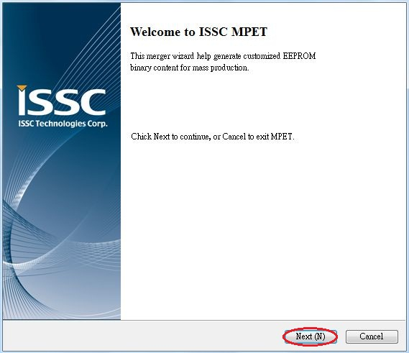

**Step2.** Select “UI Patch Only” to use full EEPROM table to merge UI and DSP parameter.

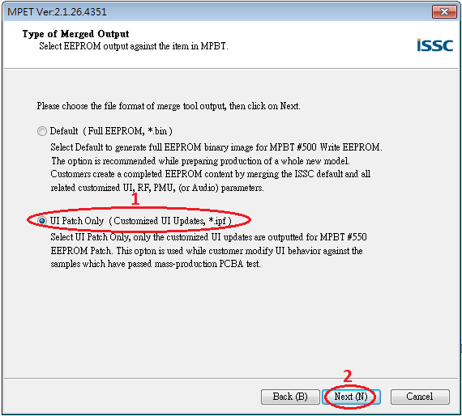

**Step3.** Select the bin file (full EEPROM table) and click “Next”

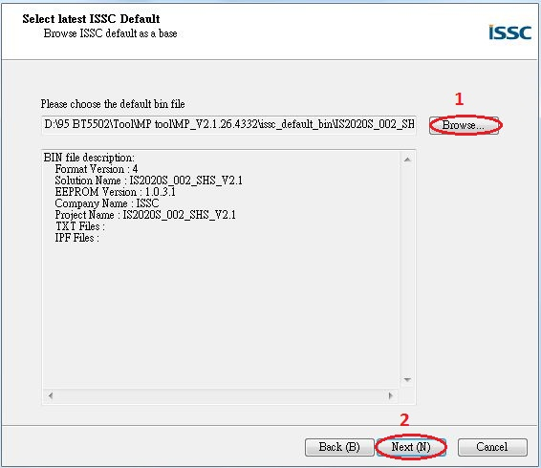

**Step4.** If the bin file had included UI, DSP or patch code parameter, you can see them in block 1 as the figure below. If you want keep the in your new system, you can select the item which you want to keep and use “pull down” button to add them to merge list. If you want to add new parameter (e.g. UI and DSP parameter), click “+” button to add these files into tool for merge with EEPROM table.

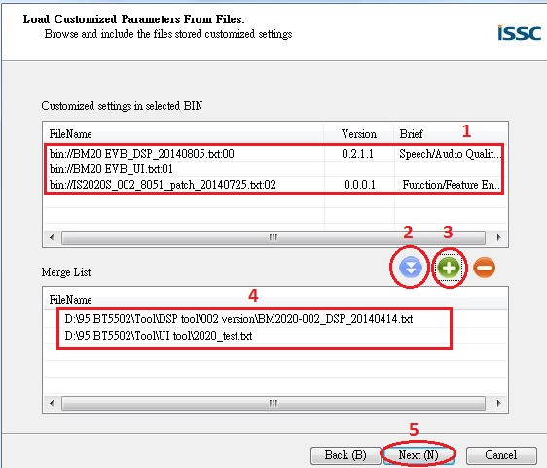

**Step5.** Select an output path and create a name for the merged EEPROM table.

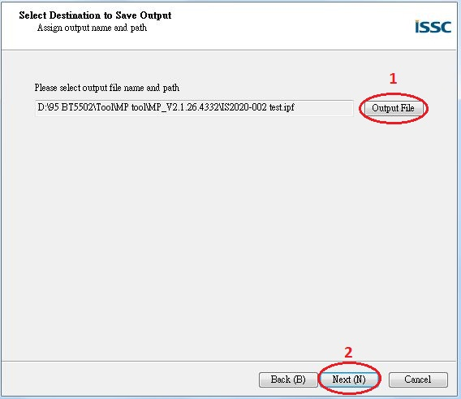

**Step6.** Click “Generate” button to generate the new EEPROM table.

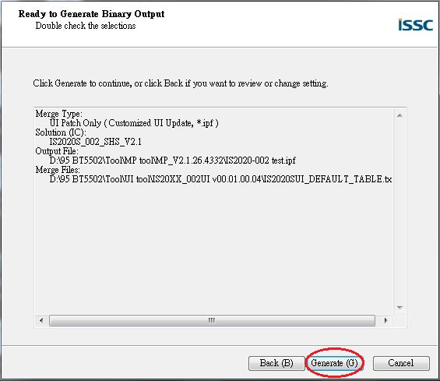

**Step7.** Select if you want use new setting of these parts.

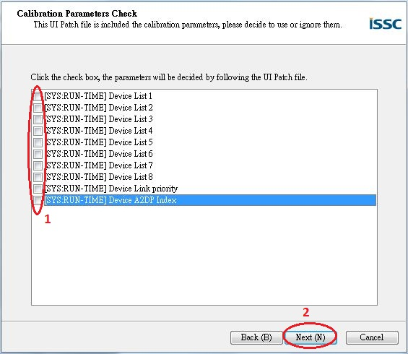

**Step8.** Now you have a merged patch file (*.ipf file).

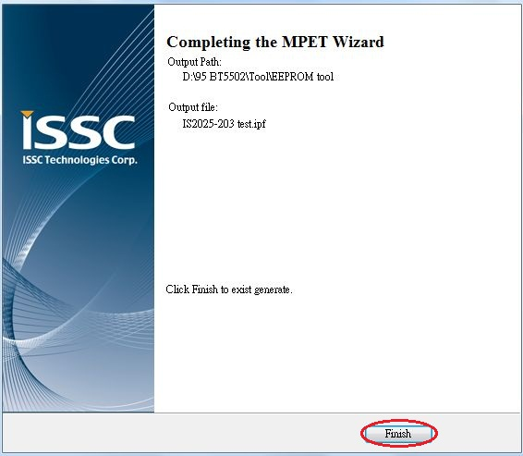

**2.4.4 Procedure to Update EEPROM Parameters**

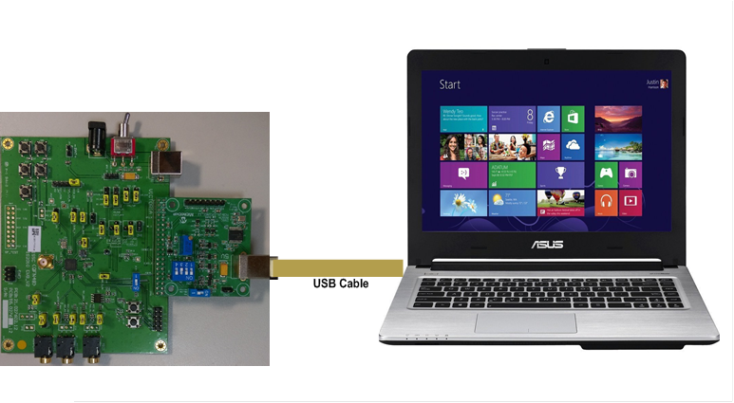

**Step 1.** Connect with a EDGAR board and make sure EDGAR SW1 in “ROM TEST” mode. (IBDK mode)

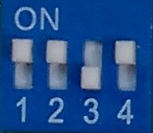

**Step 2.** Connect EDGAR board “P1” port and PC by USB cable. **LED1** & **LED2** on EVB will keep lighting.

**Step 3.** Run the **E2PROM_tool.exe** program and a window will be come up as below

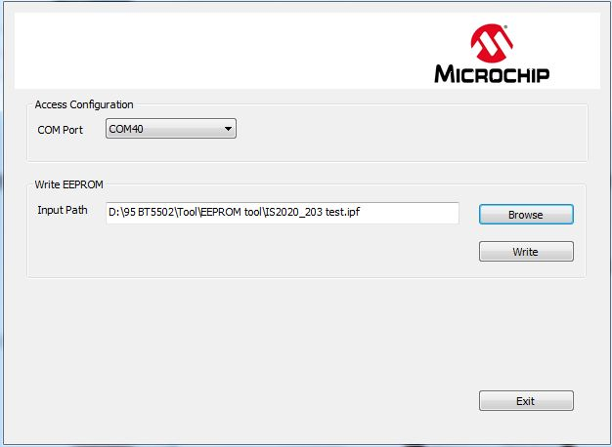

**Step 4**. Specify the **COM** Port**.**

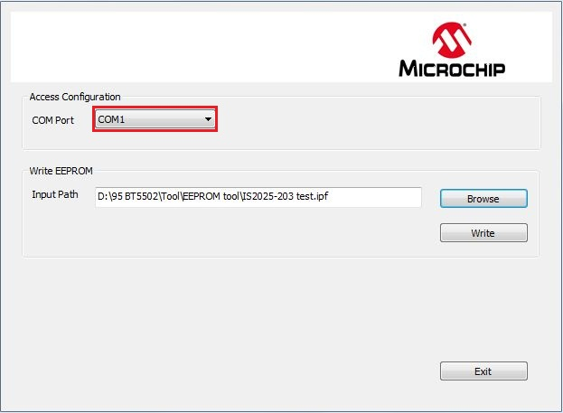

**Step5.** Press ”Browse” to choose the file where you want to write EEPROM table or patch file.

**Step6.** Press” **Write**” to write these setting to EEPROM

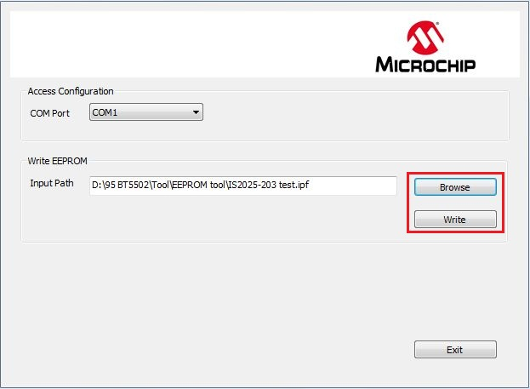

**Step7.** After finish data update, remove USB cable and EDGAR board, then make SW2 on EVB to

“ROM APP” mode and reboot.

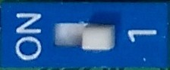

Now EVB can use the new setting after updated EEPROM parameter.

## 2.5 Silicon Configuration

**2.5.1** **Mode Settings**

Setting in Mode Switch:  
For ROM chip application

|  |  |  |  |
| --- | --- | --- | --- |
| Mode | SW12 Setting | Switch 12 PIN Definition |  |
| Test Mode |  | 1: ON (P2_0: LOW) |  |
| Application Mode |  | 1: OFF (P2_0: HIGH) |  |

# Appendix A. IS2010 Audio Evaluation Board Schematics

EVB block diagram

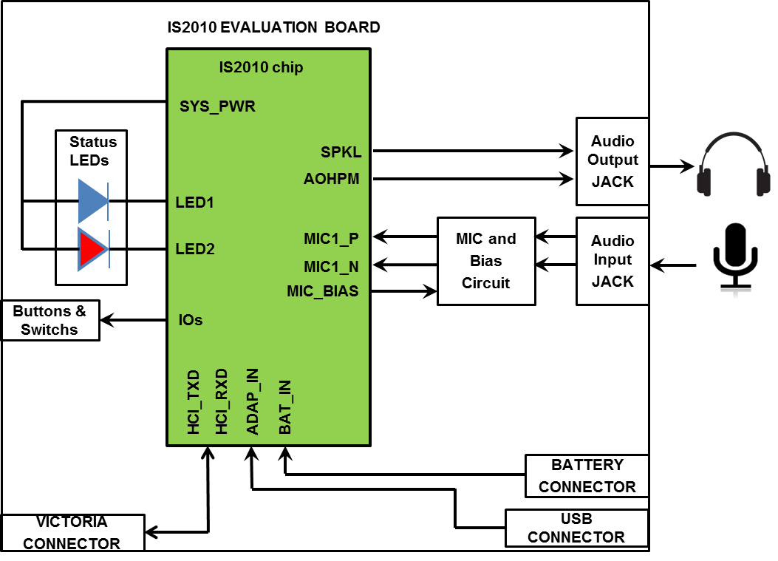









# 

# Appendix B. UART DAUGHTER BOARD (EDGAR)

IS2010 EVB reserves an interface (JP46) to connect with an UART daughter board for parameter update.

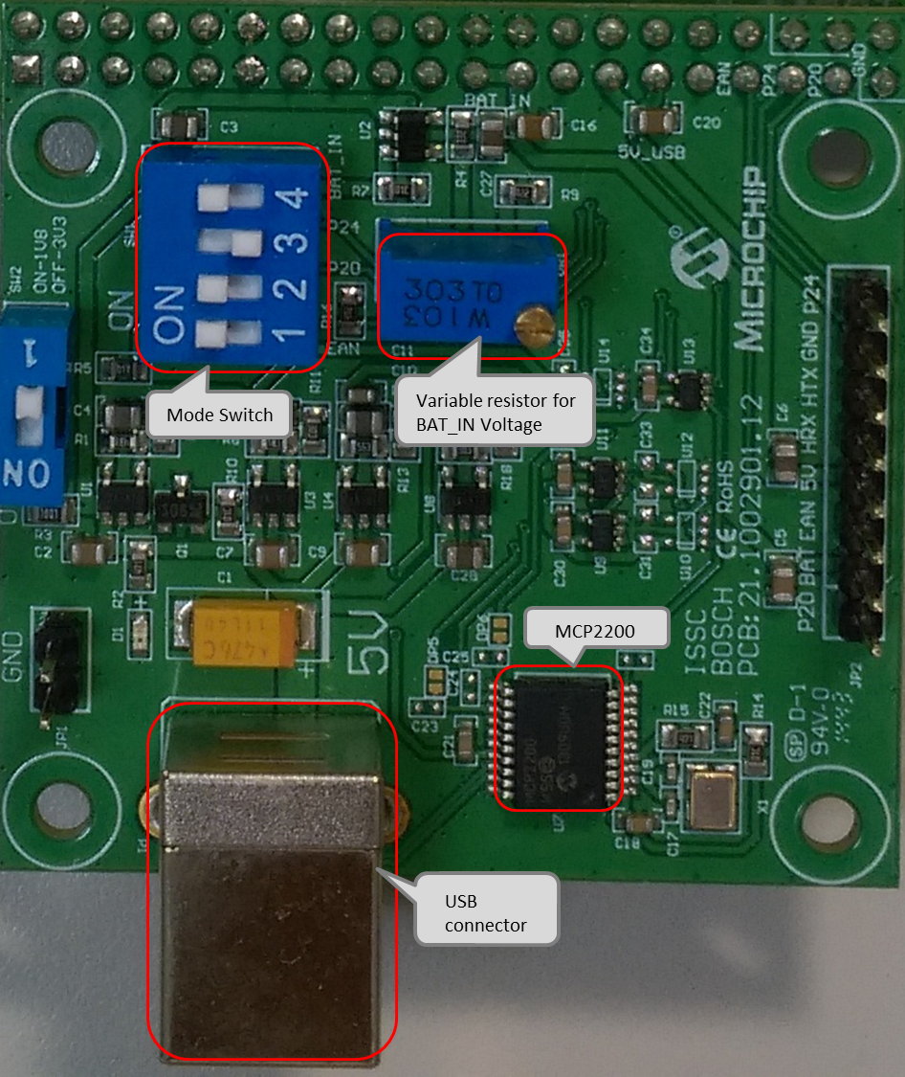

User has to connect this board to IS2010 EVB for parameter update by USB cable.

The schematics of the daughter board as below:



# 



**Worldwide Sales and Service**

##### AMERICAS

**Corporate Office**

2355 West Chandler Blvd.

Chandler, AZ 85224-6199

Tel: 480-792-7200

Fax: 480-792-7277

Technical Support: [http://www.microchip.com/ support](http://support.microchip.com/)

Web Address:

[www](http://www.microchip.com/).microchip.com

**Atlanta**

Duluth, GA

Tel: 678-957-9614

Fax: 678-957-1455

**Austin, TX**

Tel: 512-257-3370

**Boston** Westborough, MA Tel: 774-760-0087

Fax: 774-760-0088

**Chicago**

Itasca, IL

Tel: 630-285-0071

Fax: 630-285-0075

**Cleveland** Independence, OH Tel: 216-447-0464

Fax: 216-447-0643

**Dallas**

Addison, TX

Tel: 972-818-7423

Fax: 972-818-2924

**Detroit**

Novi, MI

Tel: 248-848-4000

**Houston, TX**

Tel: 281-894-5983

**Indianapolis** Noblesville, IN Tel: 317-773-8323

Fax: 317-773-5453

**Los Angeles** Mission Viejo, CA Tel: 949-462-9523

Fax: 949-462-9608

**New York, NY**

Tel: 631-435-6000

**San Jose, CA**

Tel: 408-735-9110

**Canada - Toronto**

Tel: 905-673-0699

Fax: 905-673-6509

##### ASIA/PACIFIC

**Asia Pacific Office** Suites 3707-14, 37th Floor Tower 6, The Gateway Harbour City, Kowloon Hong Kong

Tel: 852-2943-5100

Fax: 852-2401-3431

**Australia - Sydney**

Tel: 61-2-9868-6733

Fax: 61-2-9868-6755

**China - Beijing**

Tel: 86-10-8569-7000

Fax: 86-10-8528-2104

**China - Chengdu**

Tel: 86-28-8665-5511

Fax: 86-28-8665-7889

**China - Chongqing**

Tel: 86-23-8980-9588

Fax: 86-23-8980-9500

**China - Hangzhou**

Tel: 86-571-8792-8115

Fax: 86-571-8792-8116

**China - Hong Kong SAR**

Tel: 852-2943-5100

Fax: 852-2401-3431

**China - Nanjing**

Tel: 86-25-8473-2460

Fax: 86-25-8473-2470

**China - Qingdao**

Tel: 86-532-8502-7355

Fax: 86-532-8502-7205

**China - Shanghai**

Tel: 86-21-5407-5533

Fax: 86-21-5407-5066

**China - Shenyang**

Tel: 86-24-2334-2829

Fax: 86-24-2334-2393

**China - Shenzhen**

Tel: 86-755-8864-2200

Fax: 86-755-8203-1760

**China - Wuhan**

Tel: 86-27-5980-5300

Fax: 86-27-5980-5118

**China - Xian**

Tel: 86-29-8833-7252

Fax: 86-29-8833-7256

**China - Xiamen**

Tel: 86-592-2388138

Fax: 86-592-2388130

**China - Zhuhai**

Tel: 86-756-3210040

Fax: 86-756-3210049

##### ASIA/PACIFIC

**India - Bangalore**

Tel: 91-80-3090-4444

Fax: 91-80-3090-4123

**India - New Delhi**

Tel: 91-11-4160-8631

Fax: 91-11-4160-8632

**India - Pune**

Tel: 91-20-3019-1500

**Japan - Osaka**

Tel: 81-6-6152-7160

Fax: 81-6-6152-9310

**Japan - Tokyo**

Tel: 81-3-6880- 3770

Fax: 81-3-6880-3771

**Korea - Daegu**

Tel: 82-53-744-4301

Fax: 82-53-744-4302

**Korea - Seoul**

Tel: 82-2-554-7200

Fax: 82-2-558-5932 or

82-2-558-5934

**Malaysia - Kuala Lumpur**

Tel: 60-3-6201-9857

Fax: 60-3-6201-9859

**Malaysia - Penang**

Tel: 60-4-227-8870

Fax: 60-4-227-4068

**Philippines - Manila**

Tel: 63-2-634-9065

Fax: 63-2-634-9069

**Singapore**

Tel: 65-6334-8870

Fax: 65-6334-8850

**Taiwan - Hsin Chu**

Tel: 886-3-5778-366

Fax: 886-3-5770-955

**Taiwan - Kaohsiung**

Tel: 886-7-213-7830

**Taiwan - Taipei**

Tel: 886-2-2508-8600

Fax: 886-2-2508-0102

**Thailand - Bangkok**

Tel: 66-2-694-1351

Fax: 66-2-694-1350

##### EUROPE

**Austria - Wels**

Tel: 43-7242-2244-39

Fax: 43-7242-2244-393

**Denmark - Copenhagen**

Tel: 45-4450-2828

Fax: 45-4485-2829

**France - Paris**

Tel: 33-1-69-53-63-20

Fax: 33-1-69-30-90-79

**Germany - Dusseldorf**

Tel: 49-2129-3766400

**Germany - Munich**

Tel: 49-89-627-144-0

Fax: 49-89-627-144-44

**Germany - Pforzheim**

Tel: 49-7231-424750

**Italy - Milan**

Tel: 39-0331-742611

Fax: 39-0331-466781

**Italy - Venice**

Tel: 39-049-7625286

**Netherlands - Drunen**

Tel: 31-416-690399

Fax: 31-416-690340

**Poland - Warsaw**

Tel: 48-22-3325737

**Spain - Madrid**

Tel: 34-91-708-08-90

Fax: 34-91-708-08-91

**Sweden - Stockholm**

Tel: 46-8-5090-4654

**UK - Wokingham**

Tel: 44-118-921-5800

Fax: 44-118-921-5820

 2015 Microchip Technology Inc. **Advance Information** page 34